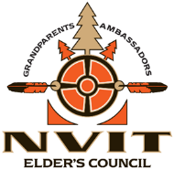 NVIT Elders 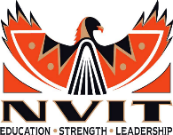
Ambassadors – Grandparents – Good Medicine

If you are wanting or needing supports: spiritually, mentally, physically or emotionally, please reach out to our Elders.

To connect with NVIT Elders, please contact Pat Brown, Elders Council Coordinator: pabrown@nvit.ca

