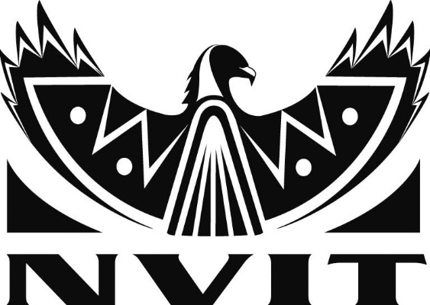
INFORMATION LITERACY PROGRAM
of Robert W. Sterling Memorial Library
RECIPROCAL BORROWING

By: Rita Cavaliere, Librarian rcavaliere@nvit.bc.ca 250-378-3303
What is Reciprocal Borrowing?

Current students & employees of publicly funded B.C. post-secondary institution are granted on-site borrowing privileges at another B.C. post-secondary institution library, free of charge & that permission is reciprocated.

Policy
CPSLD members agree to the principle of reciprocal borrowing between libraries for students & employees & will implement the practice of reciprocal borrowing if possible & within the mandate of the institution.

Procedure
Students & employees must present valid identification from their institution when borrowing materials from another institution library. Reciprocal borrowers are registered at the lending library according to the lending library’s practice (e.g. expiry date established by lending library).
Loan policies e.g. types of items loaned, number of items, length of borrowing period) of the lending library are followed. Materials must be returned to the lending library and will not be cleared from the borrower’s record until they reach the lending library. Any costs (for overdue fines, damaged or lost materials) are paid by the borrower to the lending library.
Current Reciprocal Borrowing Agreements

As of September 2008, all libraries have confirmed the information below is correct

- Libraries which do full reciprocal borrowing

The following libraries extend free reciprocal borrowing privileges to students and employees:

- British Columbia Institute of Technology  - Camosun College  - Capilano University  - College of New Caledonia  - College of the Rockies  - Douglas College  - Emily Carr University of Art and Design  - Kwantlen Polytechnic University  - Langara College  - Nicola Valley Institute of Technology  - North Island College  - Northern Lights College | - Okanagan College  - Quest University  - Royal Roads University  - Selkirk College  - Simon Fraser University  - Thompson Rivers University  - Trinity Western University  - University of the Fraser Valley  - University of British Columbia  - University of Northern BC  - University of Victoria  - Vancouver Community College  - Vancouver Island University  - Yukon College

